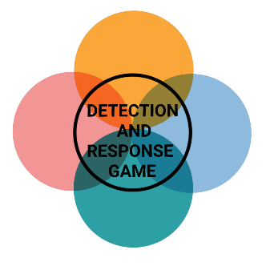

**PERSISTENCE**



**PERSISTENCE**



**PERSISTENCE**



**PERSISTENCE**

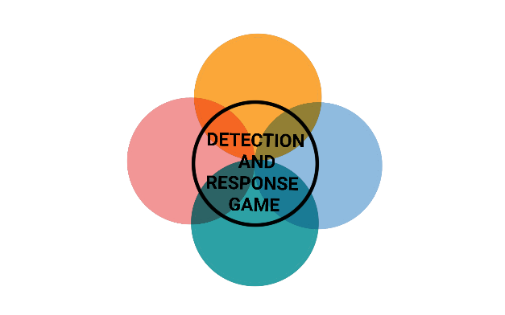

**INITIAL ACCESS**



**INITIAL ACCESS**



**INITIAL ACCESS**



**INITIAL ACCESS**



**PERSISTENCE**



**PERSISTENCE**



**PERSISTENCE**



**PERSISTENCE**

**SYSTEM FIRMWARE**

The hacker overwrites the BIOS firmware with custom updates that allow him persistence.

MITIGATION

Regular BIOS and EFI patches

DETECTION

Monitoring for system firmware manipulation

**LOGON SCRIPT**

The hacker uses the Windows logon script which is executed when a certain user logs in to achieve persistence.

MITIGATION

Proper permissions for registry hives

DETECTION

Monitor for changes to registry values

**DOMAIN ACCOUNT**

The hacker creates a new domain account that he can access at any time.

MITIGATION

Multi-factor authentication

DETECTION

Monitor for account creation without naming scheme

**SSH AUTHORIZED KEYS**

The hacker adds their own public key to the SSH authorized_keys file to maintain persistence.

MITIGATION

Restrict access to the authorized_keys file

DETECTION

Monitor the authorized_keys file



**INITIAL ACCESS**



**INITIAL ACCESS**



**INITIAL ACCESS**



**INITIAL ACCESS**

**BOOTKIT**

The hacker installs a bootkit that looks like a Microsoft Net.exe utility and enables him to deliver backdoors.

MITIGATION

Secure or trusted boot process

DETECTION

Integrity checking on MBR and VBR

**PORT KNOCKING**

The hacker sends connection attempts to closed ports in a certain order which leads to the opening of a port.

MITIGATION

Stateful firewalls

DETECTION

Monitor for extraneous packets

**EXTERNAL REMOTE SERVICES**

The hacker uses Windows Remote Management with a valid account to have access to the systems at any time.

MITIGATION

Block unnecessary remote services

DETECTION

Monitor for access outside of normal business hours

**SCHEDULED TASK**

The hacker uses at.exe to execute malicious code at specified intervals.

MITIGATION

Run tasks under the authenticated account

DETECTION

Monitor for svchost.exe executions